**Program 5. Cleaning Data with Text Functions: use of UPPER and LOWER, TRIM function, Concatenate.**

* **UPPER and LOWER Functions:** These functions convert text to uppercase or lowercase, respectively.
* **TRIM Function:** This function removes extra spaces from the beginning and end of text, and also reduces multiple spaces between words to a single space.
* **CONCATENATE Function:** This function combines text from multiple cells into a single cell.

### Step 1: Convert Text to UPPERCASE or lowercase:

1. **Create a new column (B) for UPPERCASE:**
   * In cell B2, enter the formula **=UPPER(A2)** and drag it down.

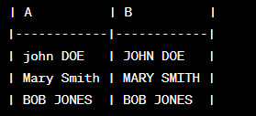

1. **Create another column (C) for LOWERCASE:**

* In cell C2, enter the formula **=LOWER(A2)** and drag it down.

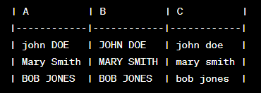

### Step 2: Use TRIM function:

1. **Create a new column (D) for TRIMMED names:**
   * In cell D2, enter the formula **=TRIM(A2)** and drag it down.

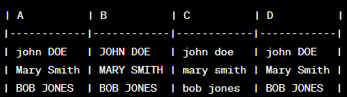

### Step 3: Concatenate Names:

1. **Create a new column (E) for CONCATENATED names:**
   * In cell E2, enter the formula **=CONCATENATE(B2, " ", C2)** to concatenate UPPERCASE and LOWERCASE names.

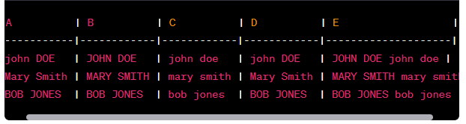

**Program 6. Cleaning Data Containing Date and Time Values: use of DATEVALUE function, DATEADD and DATEDIF, TIMEVALUE functions.**

Let's assume you have a column with date and time values in various formats:

| **A** |
| --- |
| 2022-01-25 |
| 01/25/2022 |
| 25-Jan-2022 |
| 2022-01-25 10:30 |
| Jan 25, 2022 10:30 AM |

### Step 1: Use the DATEVALUE Function:

1. **Create a new column (B) for cleaned dates:**
   * In cell B2, enter the formula **=DATEVALUE(A2)** and drag it down.

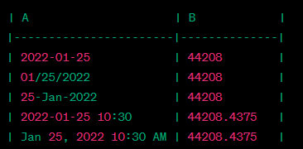

* + The DATEVALUE function converts various date formats into Excel's serial number format.

### Step 2: Use DATEADD and DATEDIF Functions (Optional):

* If you need to extract components like the day, month, or year, use the DATEADD and DATEDIF functions.

1. **Create a new column (C) for the extracted day:**
   * In cell C2, enter the formula **=DATEDIF(DATE(1900,1,1), B2, "d")** to calculate the number of days.

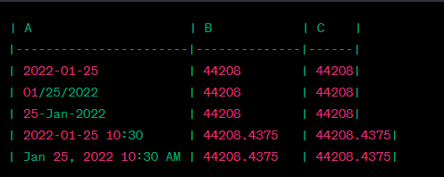

* + The DATE function creates a date in Excel serial number format (here, 1900-01-01), and DATEDIF calculates the difference in days.

### Step 3: Use the TIMEVALUE Function:

1. **Create a new column (D) for cleaned times:**
   * In cell D2, enter the formula **=TIMEVALUE(A2)** and drag it down.

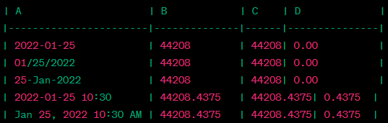

* + The TIMEVALUE function extracts the time part of the date-time value.
* Adjust the formulas based on the structure of your data and the specific cleaning requirements.
* Excel stores dates and times as serial numbers, where 1 represents the date 1900-01-01.
* The DATEADD function is not native to Excel. If necessary, you can use alternative approaches like the **+** and **-** operators to perform date arithmetic.

By using these functions, you can clean and standardize your date and time data, making it more suitable for analysis in Excel.